Tableau Project

**Comparison of Region Based on Sales**

**Submitted by**

**KAVERI**

Description

The director of a leading organization wants to compare the sales between two regions. He has asked each region operators to record the sales data to compare by region. The upper management wants to visualize the sales data using a dashboard to understand the performance between them and suggest the necessary improvements.

**Objective**

 Help the organization by creating a dashboard to visualize the sales comparison between two selected regions.

**Dataset**

 Sample Superstore

Steps To Perform

* Task 1

1. Select Sample Superstore as Dataset

* Use Sample Superstore Dataset
* Select Data
* Use Group by from Data Source Table on a Folder to create a folder to segregate the required data for Customer Name and Order ID in order to organize the data thoroughly.

**Use Sample Superstore Dataset**

Step 1

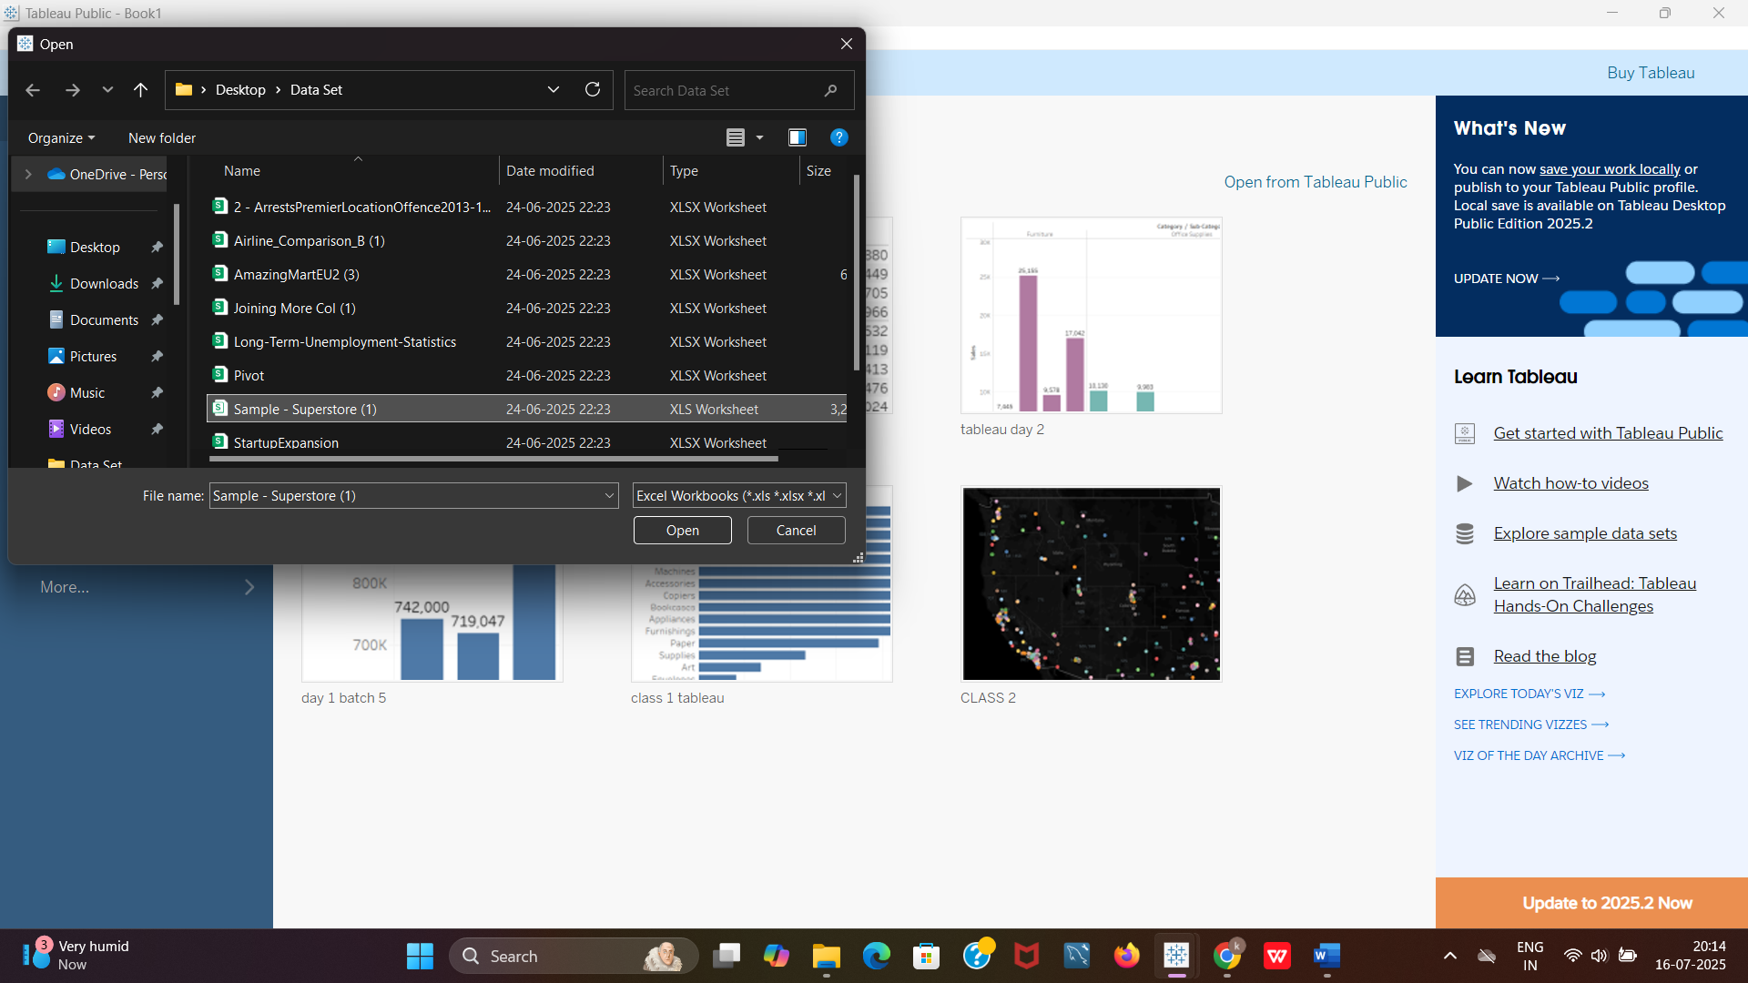

Step 2 **Select Data**

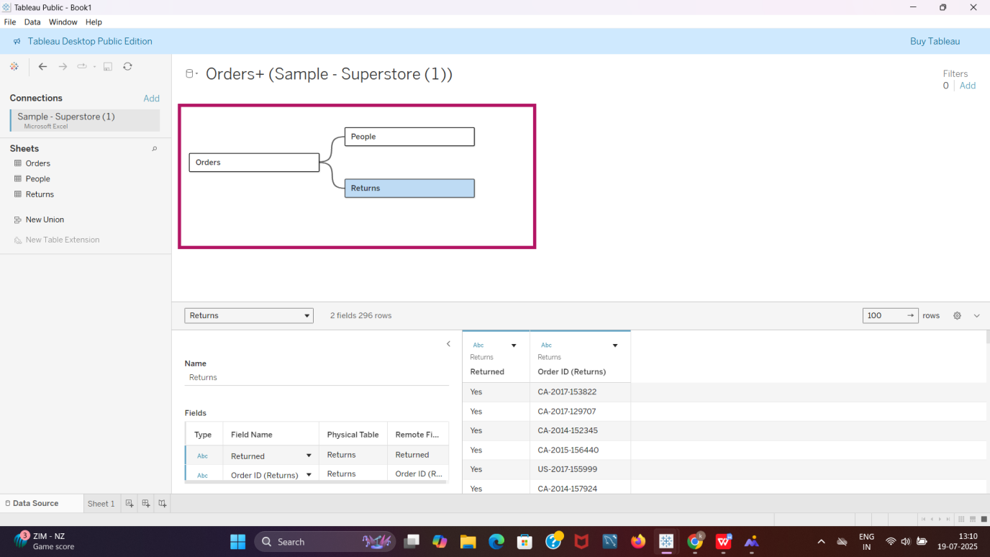

Step 3

Use Group by from Data Source Table on a Folder to create a folder to segregate the required data for Customer Name and Order ID in order to organize the data thoroughly.

* Select “Group by Folder” from data pane.

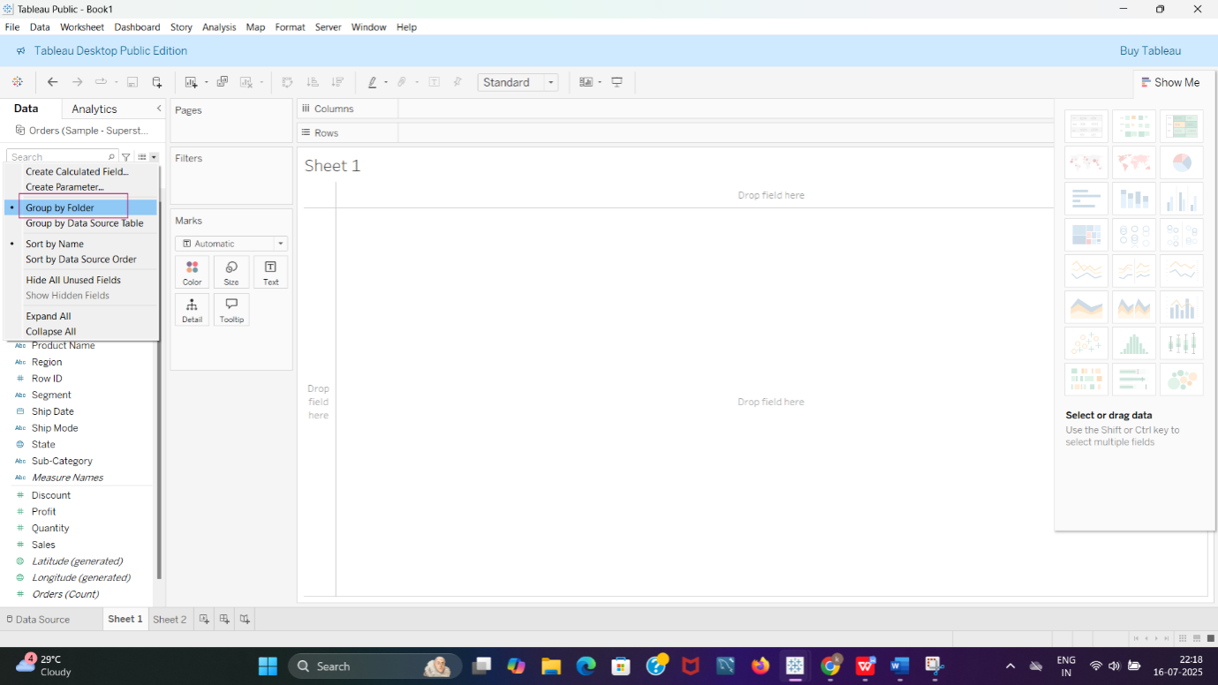

* Select customer name, press control key and select Order id and then select folders from the drop down of customer name.

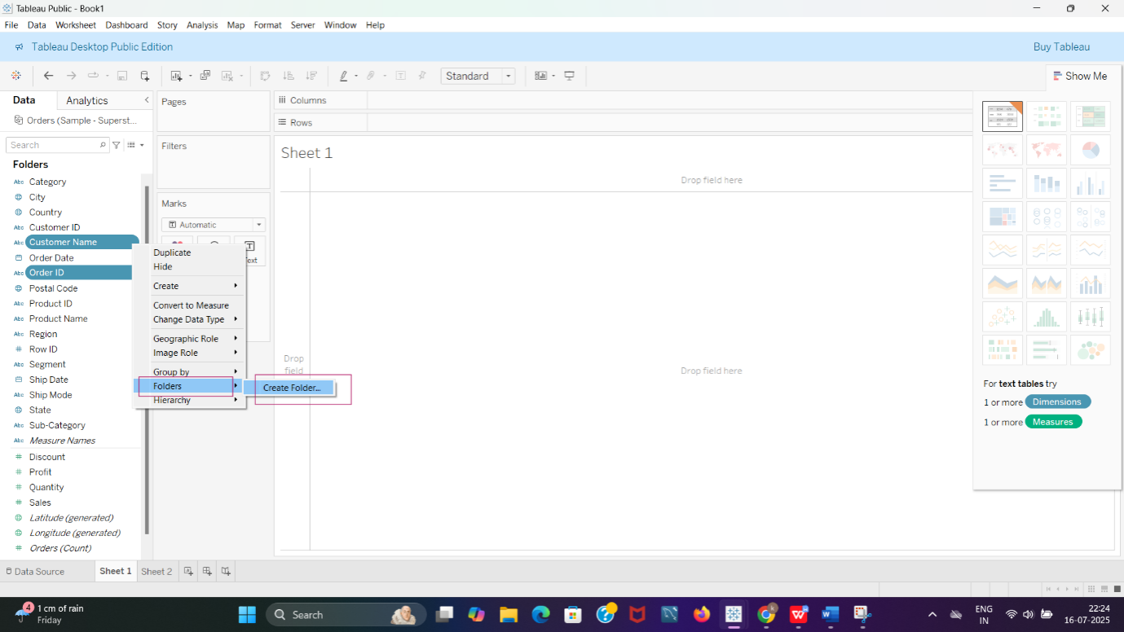

* Give a folder name

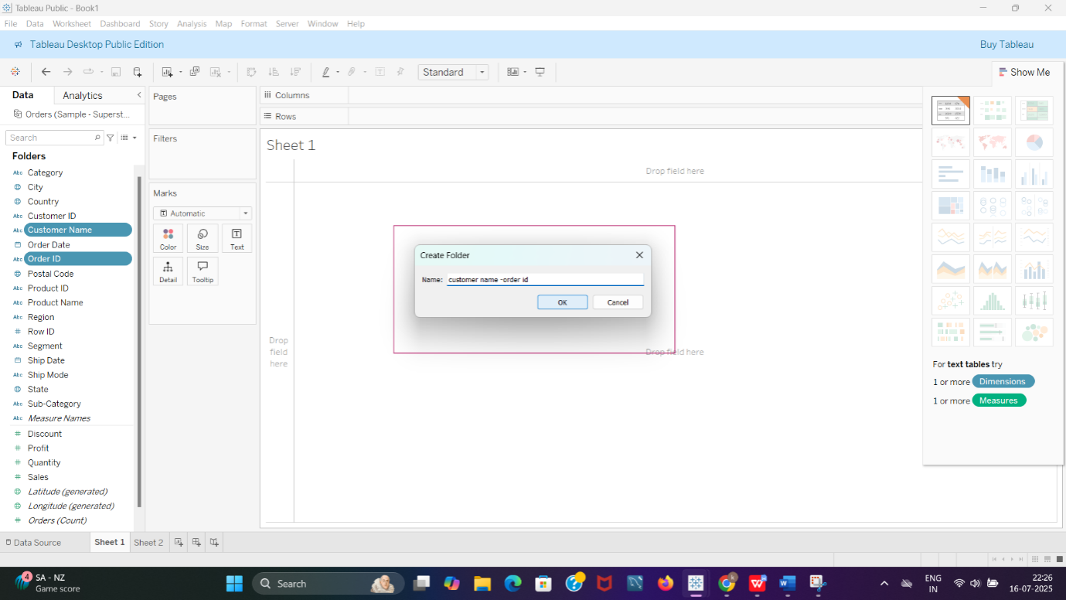

* Folder is created

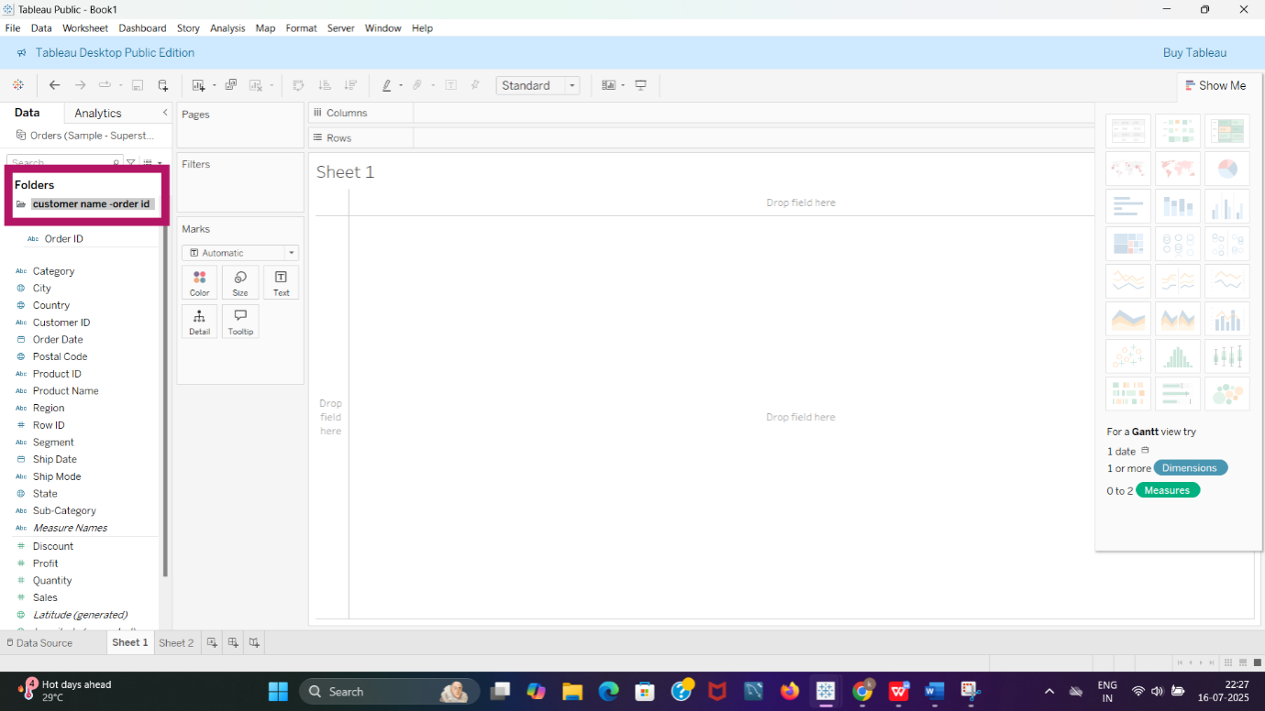

* TASK 2

**Create a hierarchy called Location for the variable Country.**

Step 1

* We select the highest order of hierarchy (Country) and create a hierarchy for the variable.

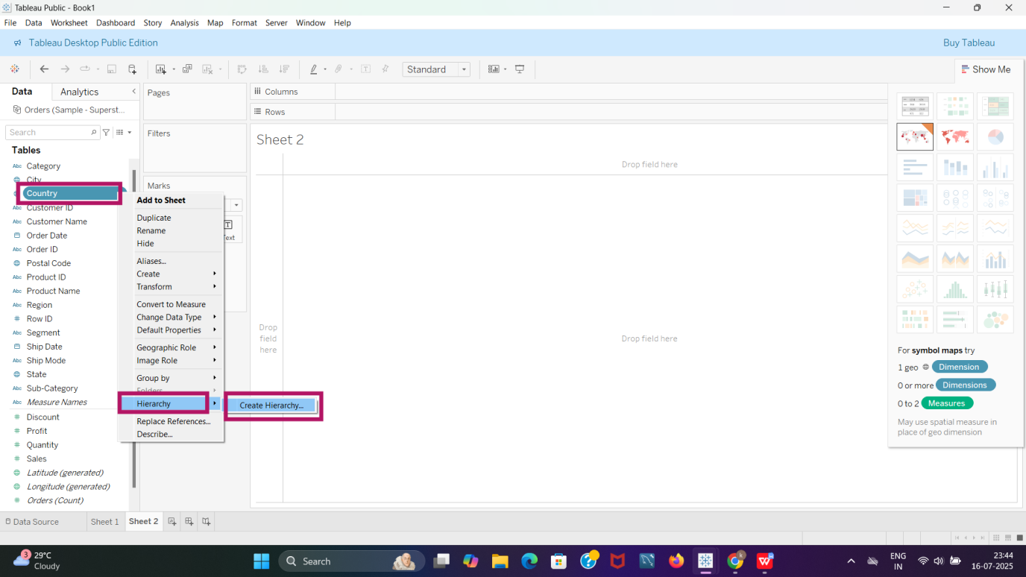

Step 2

* We rename it as LOCATION.

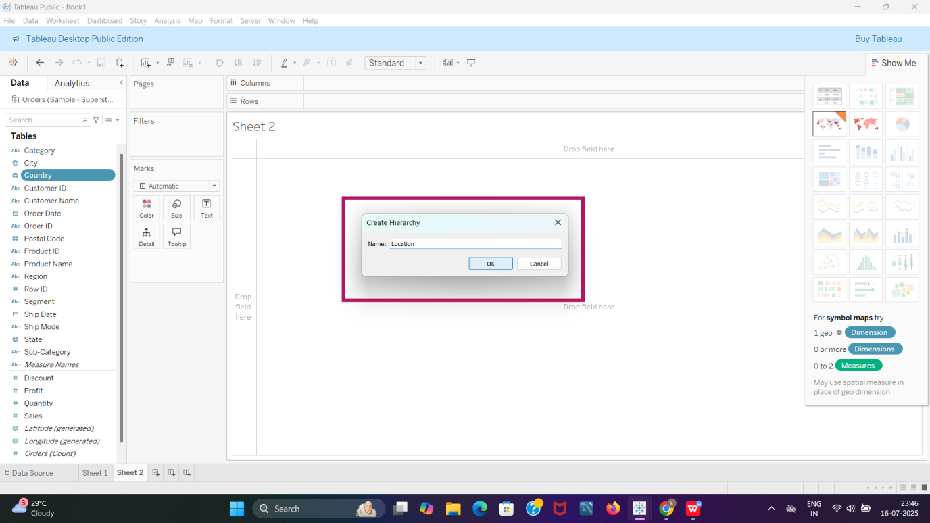

Step 3

* We select the city and add it to the hierarchy named location.

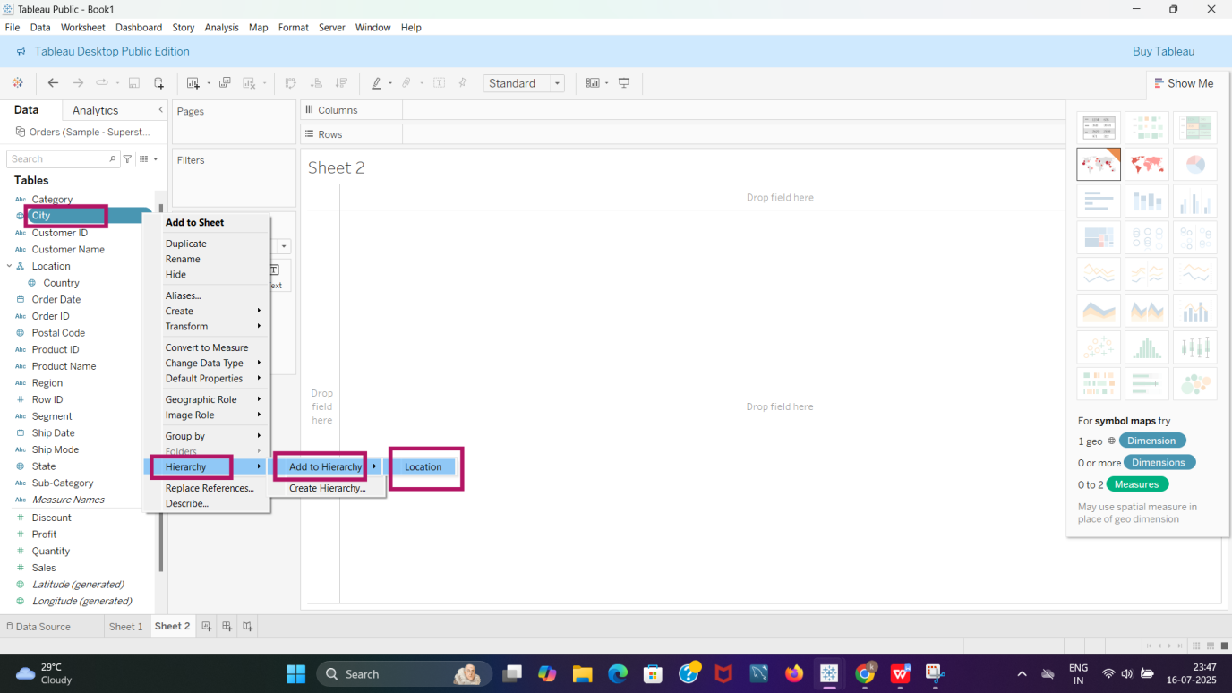

Step 4

* We select STATE and add it to hierarchy named LOCATION.

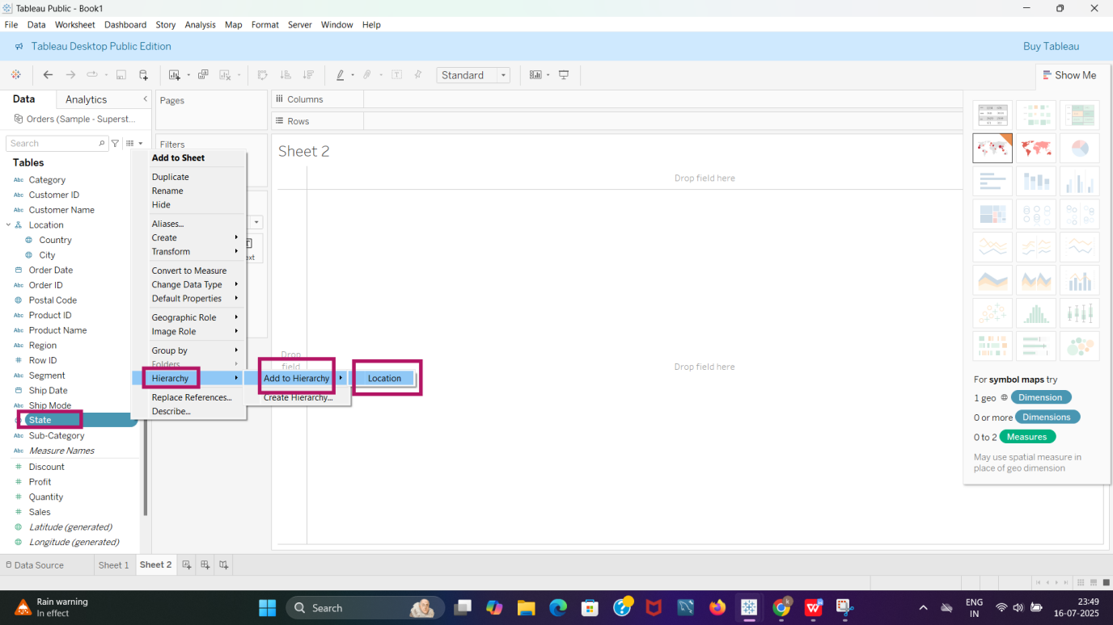

Step 5

* We select Region and add it to the hierarchy called LOCATION.

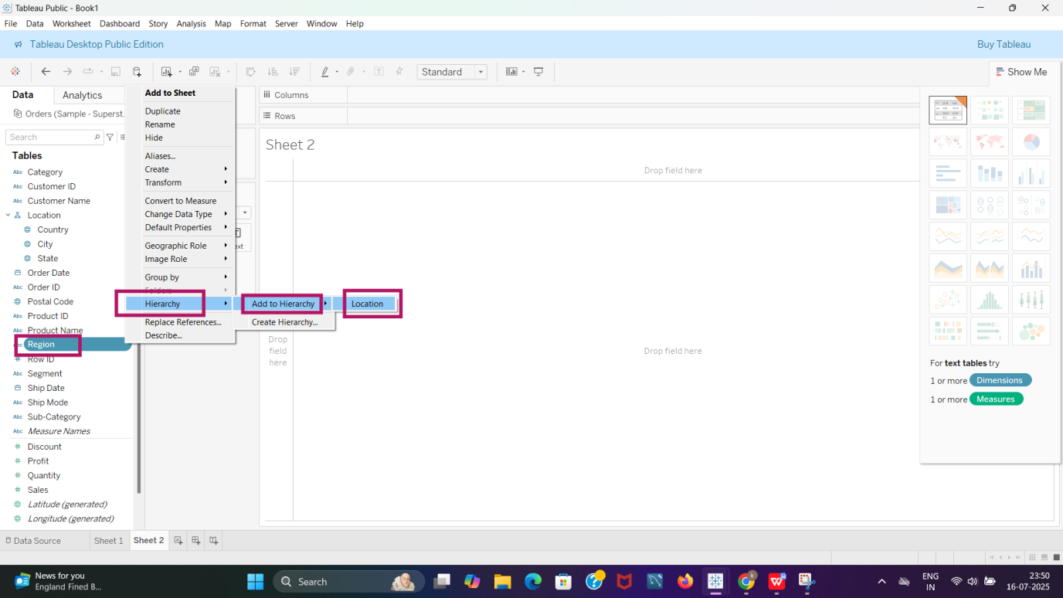

Step 6

* We select Postal Code and add it to the hierarchy called LOCATION

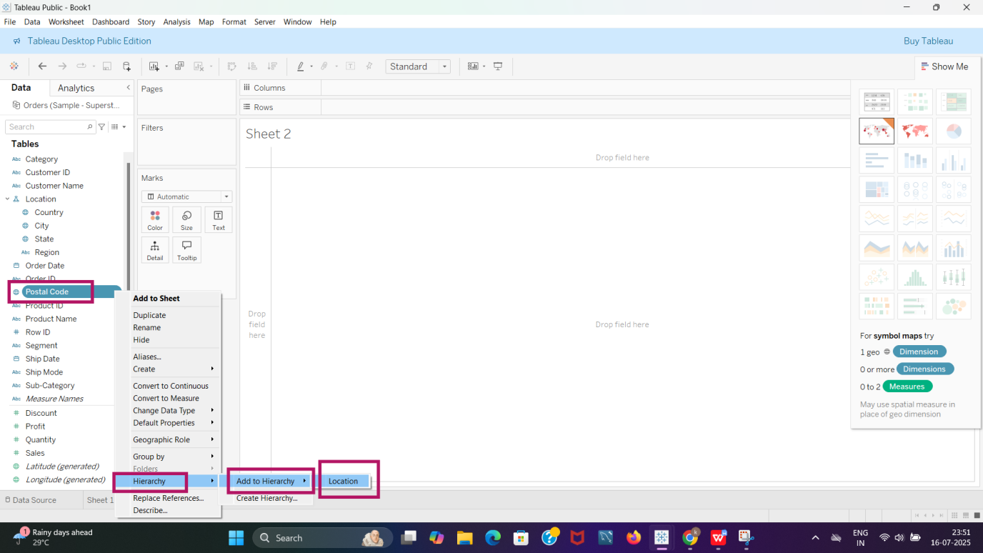

Step 7

* A hierarchy is created for the variable COUNTRY named as LOCATION.

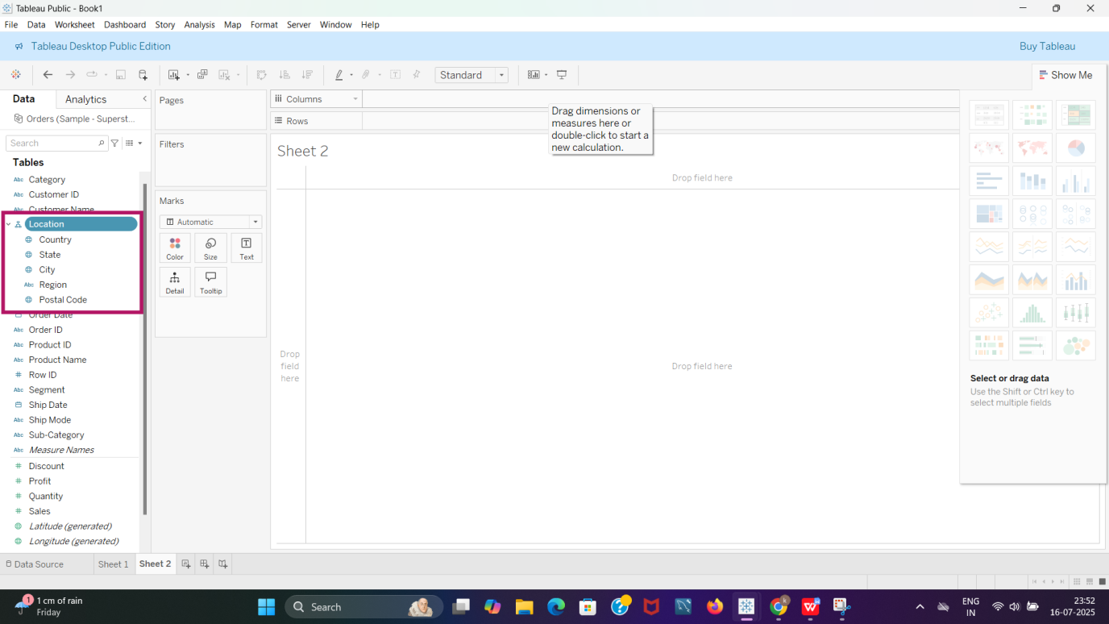

* Task 3

Create two parameters: Primary Region and Secondary Region with all regions listed in them. Here, primary and secondary region are the two regions where the sales are being compared.

1)Create Parameters for Primary Region and Secondary Region

Step 1- Select “Create Parameter”

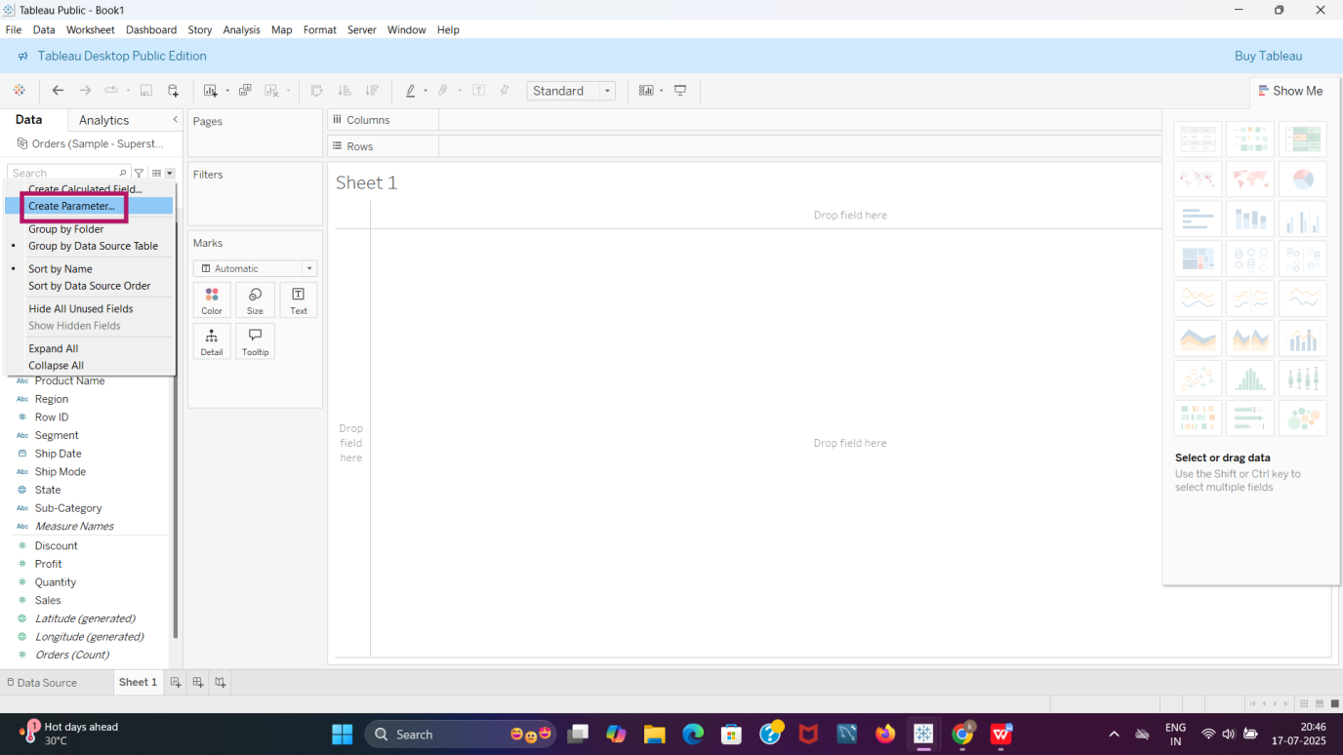

Step 2

* Create “Primary Region” Parameter.

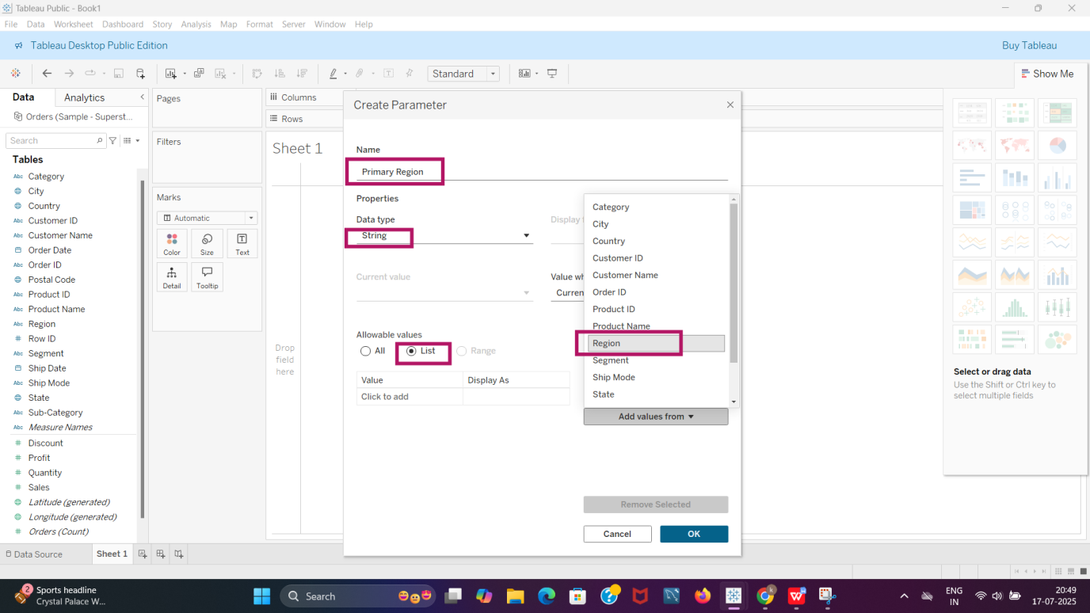

Step 3

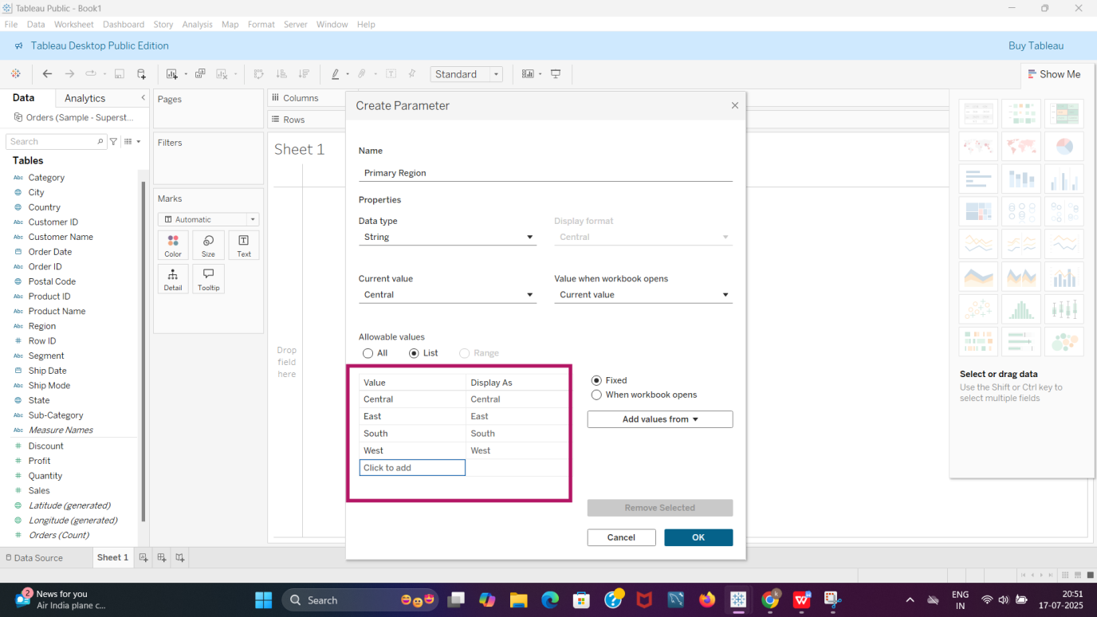

Step 4- “Primary Region” Parameter is created.

Step 5

* “Secondary Region” Parameter is created.

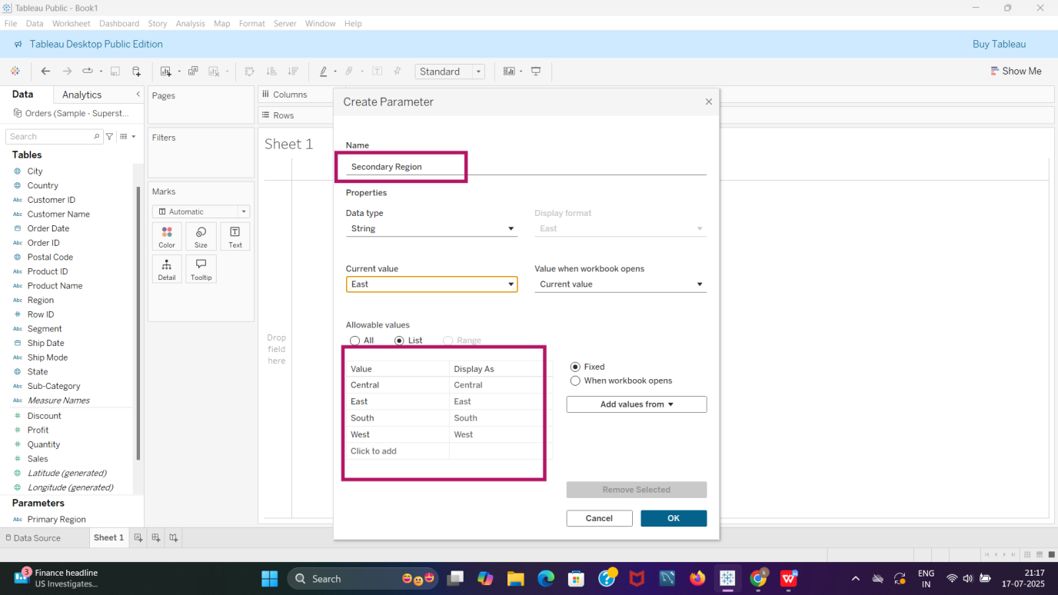

Step 6

* Parameters for Primary and secondary Region is created.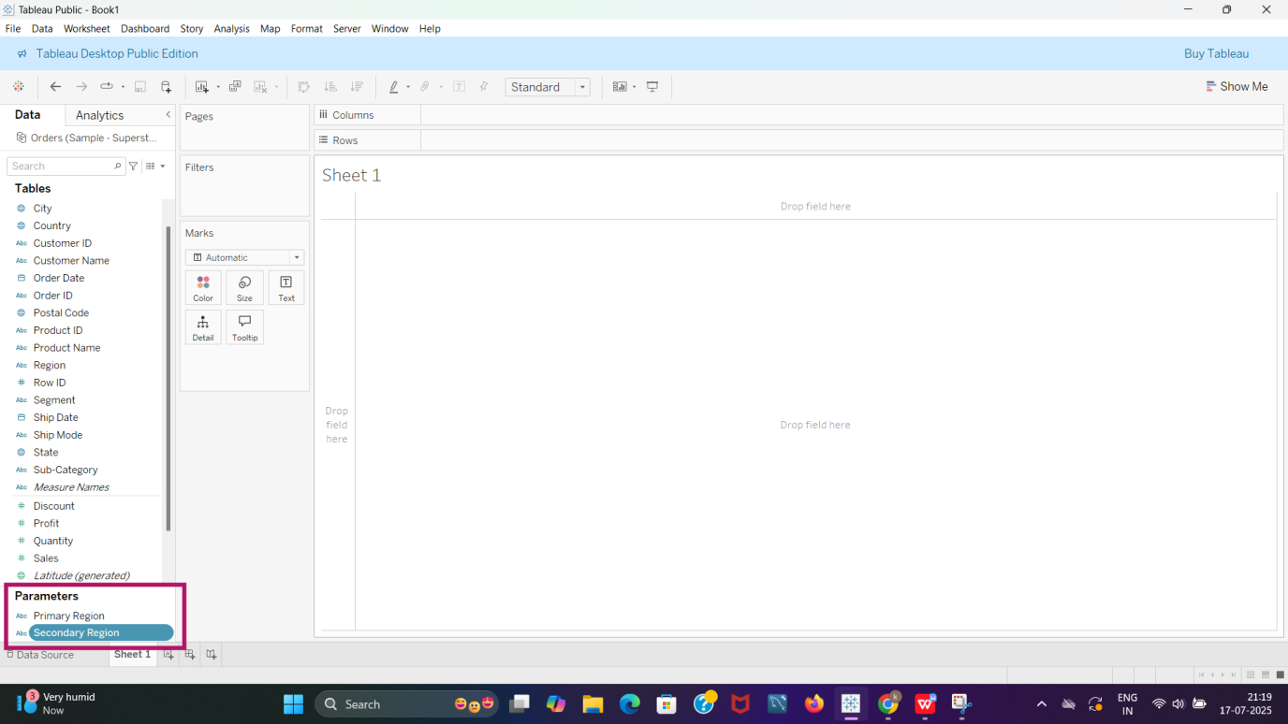2)Create a Calculated Field for both Primary Region and Secondary Region.

Step 1

* Select “Create Calculated Field”.

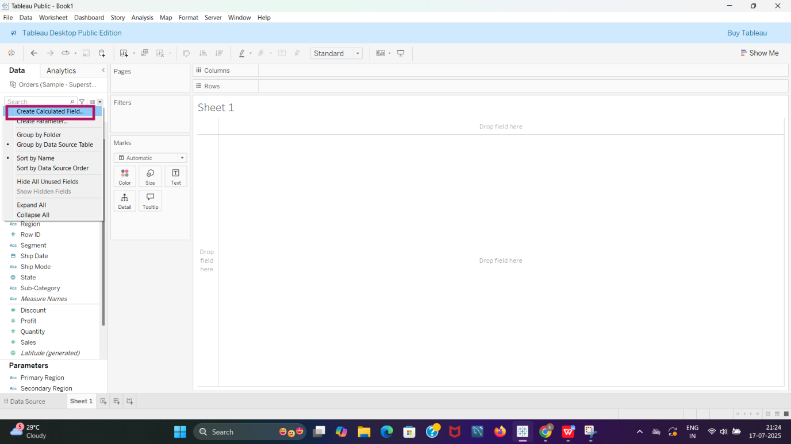

Step 2

* Create “Primary Region” Calculated Field”.

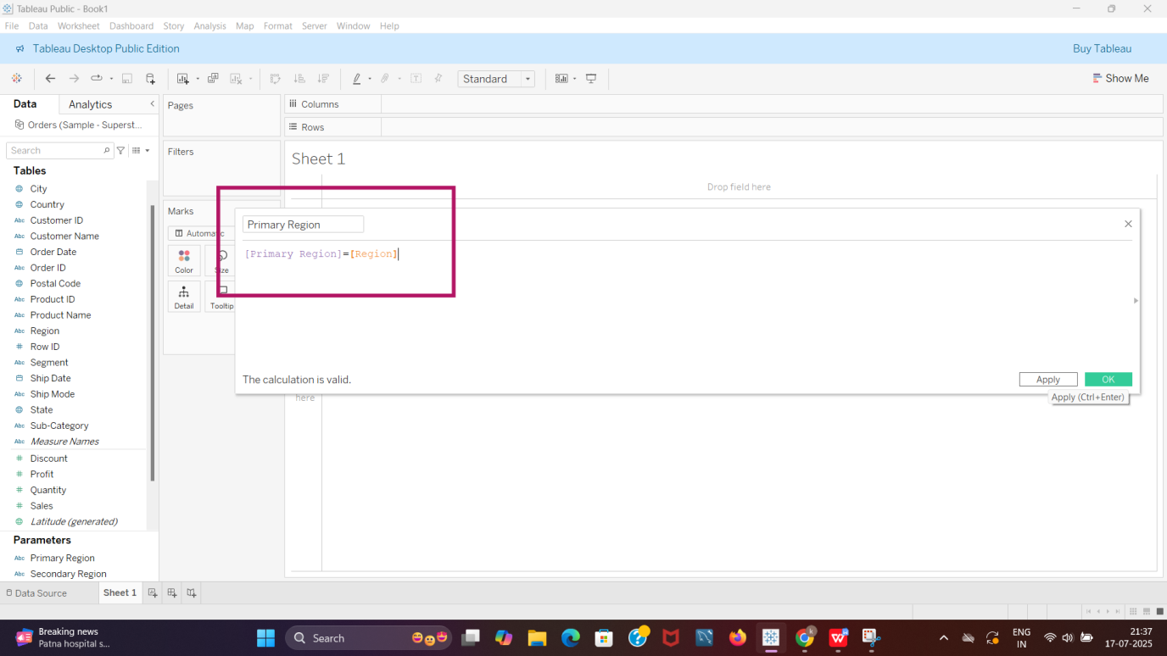

Step 3

* Create “Secondary Region” Calculated Field.

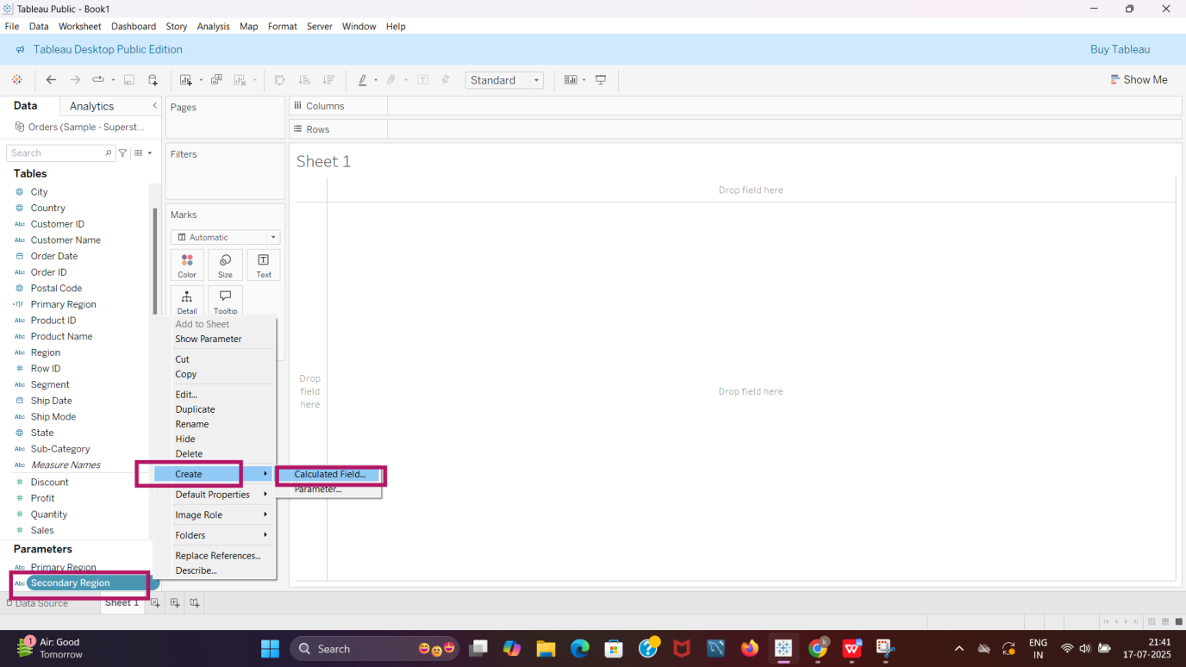

Step 4

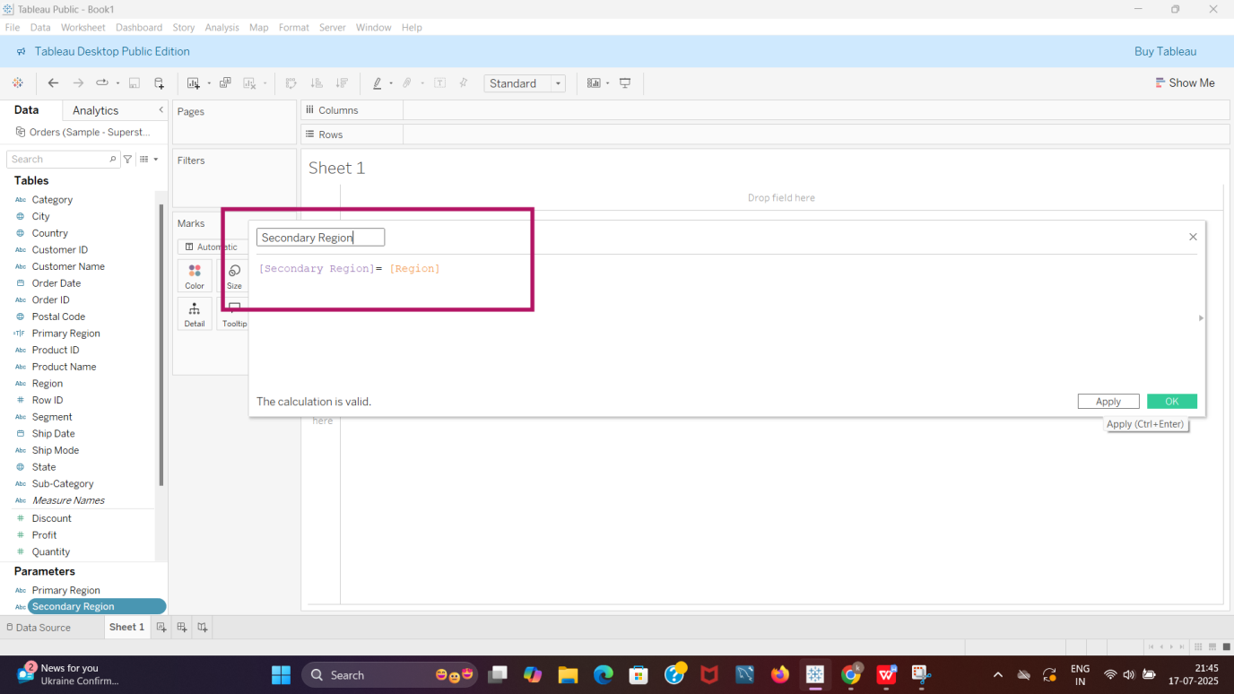

Step 5

* Primary and secondary Region Parameters created.
* Primary and secondary region calculated fields created.

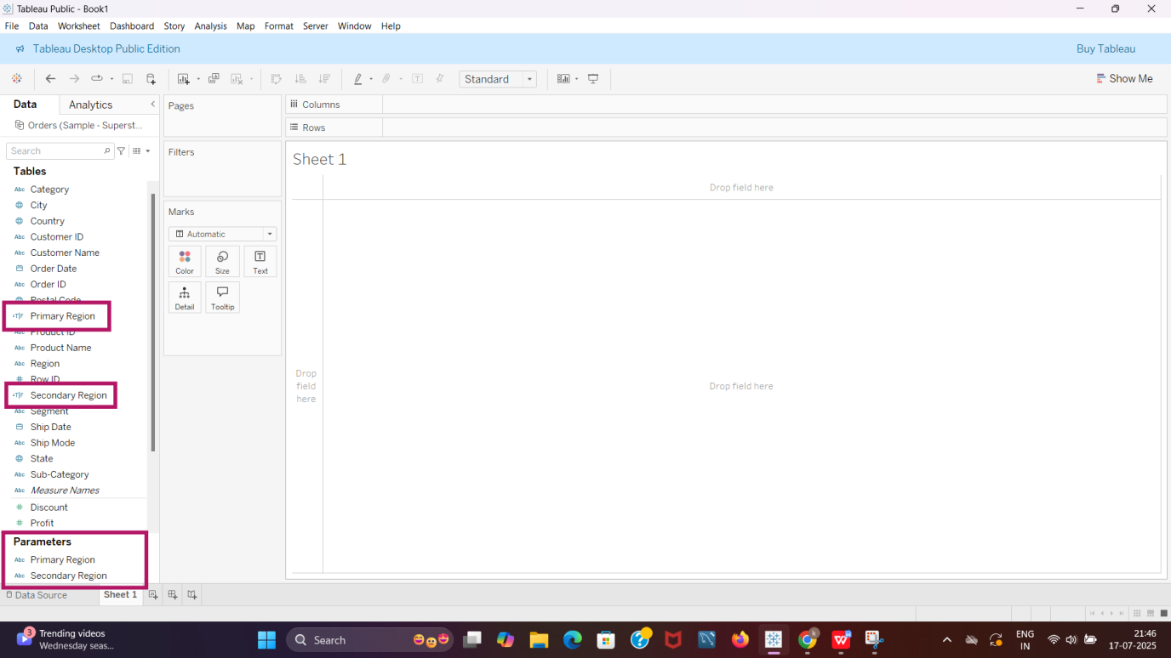

* Here we have considered the **Central region** as the **Primary Region** and the **East region** as the **Secondary Region**

**Task 4**

Create a First Order Date.

1)Create a Calculated Field and name it as the First Order Date.

Step 1 Select “**create calculated field**” Analytics pane.

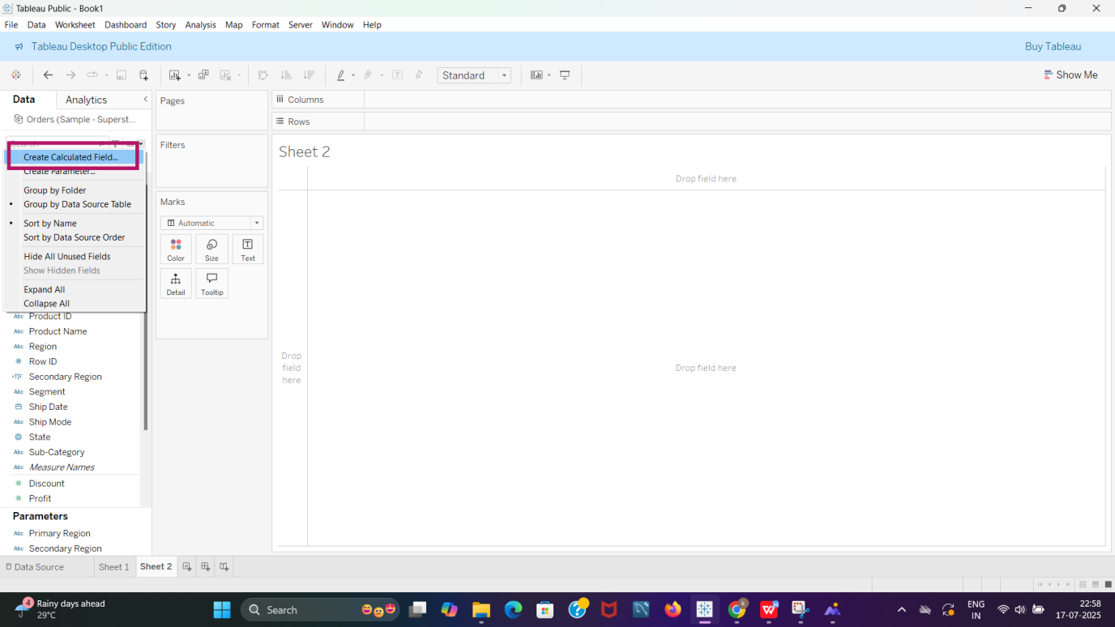

Step 2

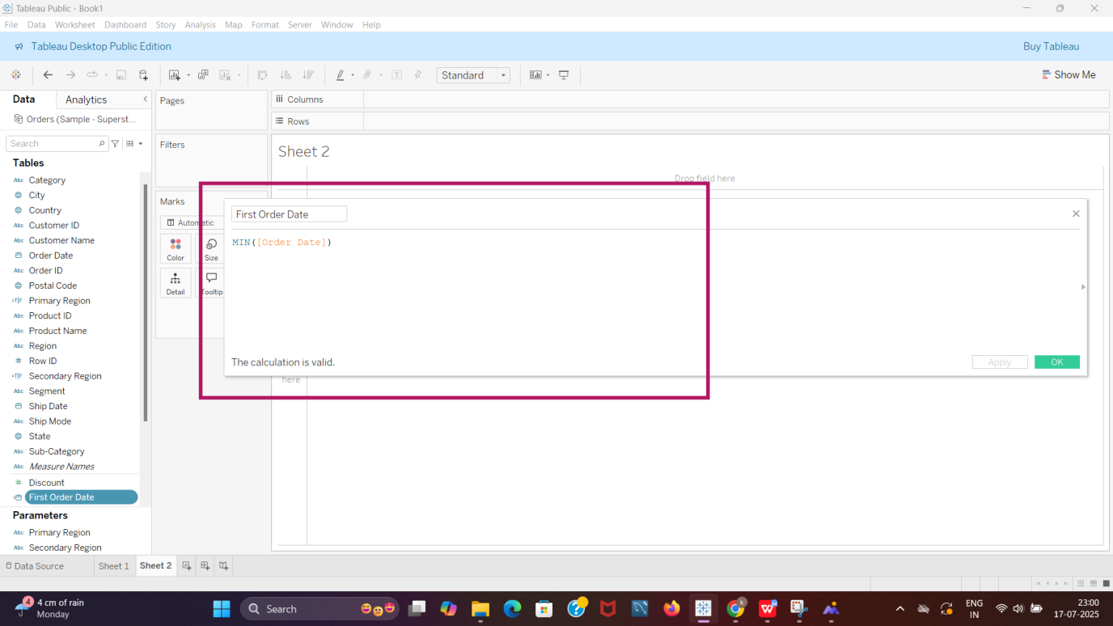

Step 3 **First Order date** is created.

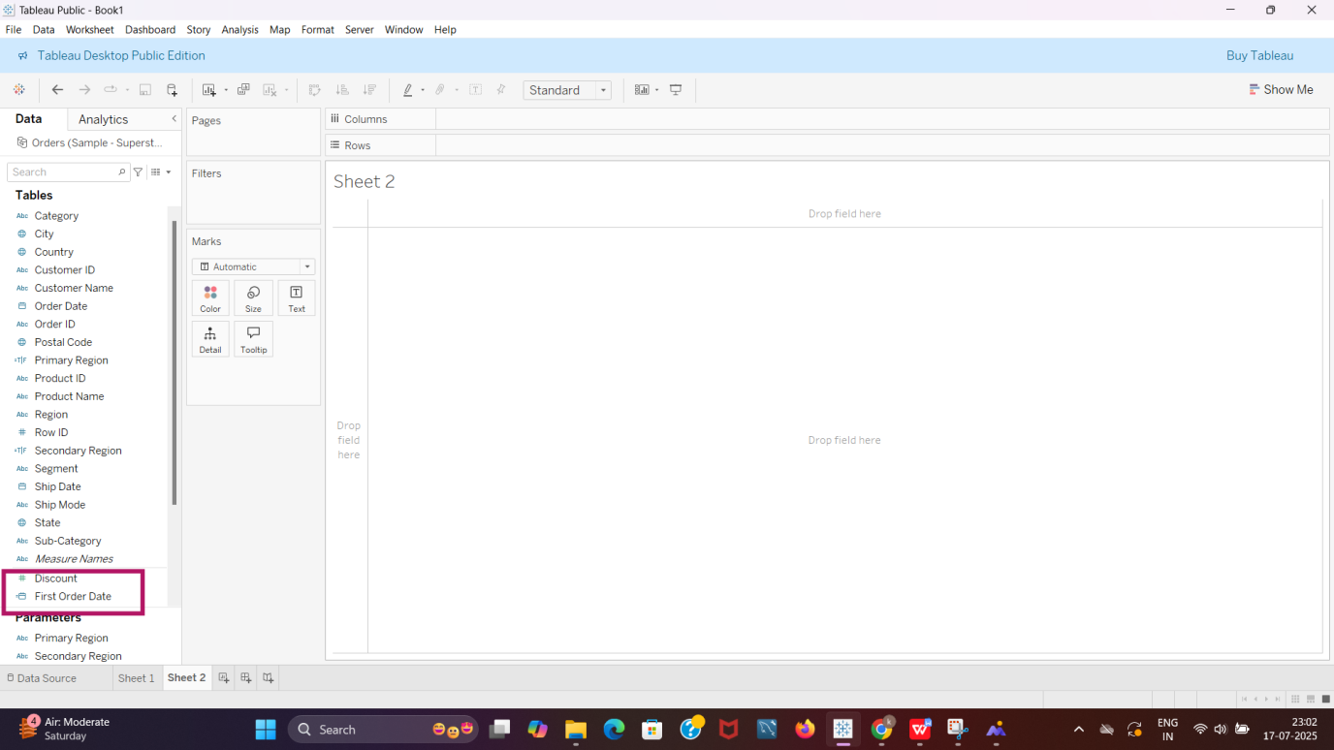

**Task 5**

**Step 1**

* **First Order Date**
* **Primary Region- Central**

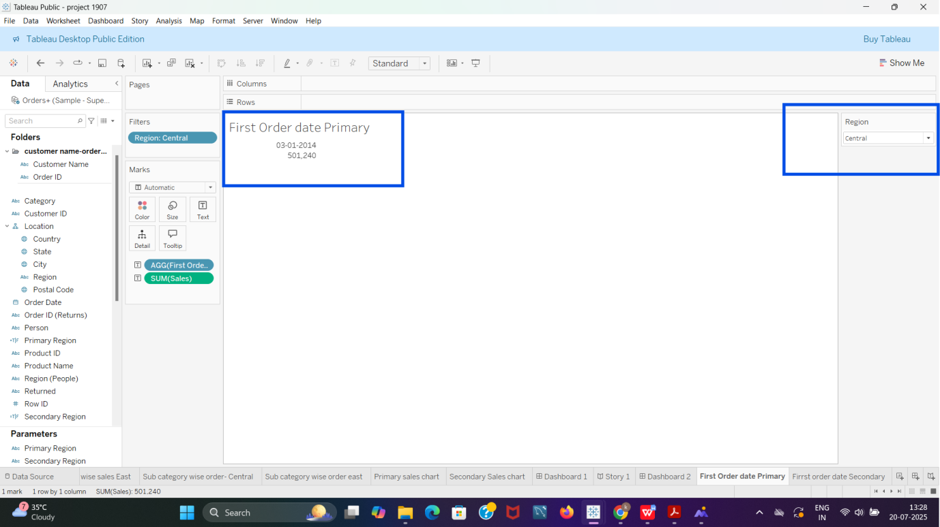

* **Secondary Region- East**

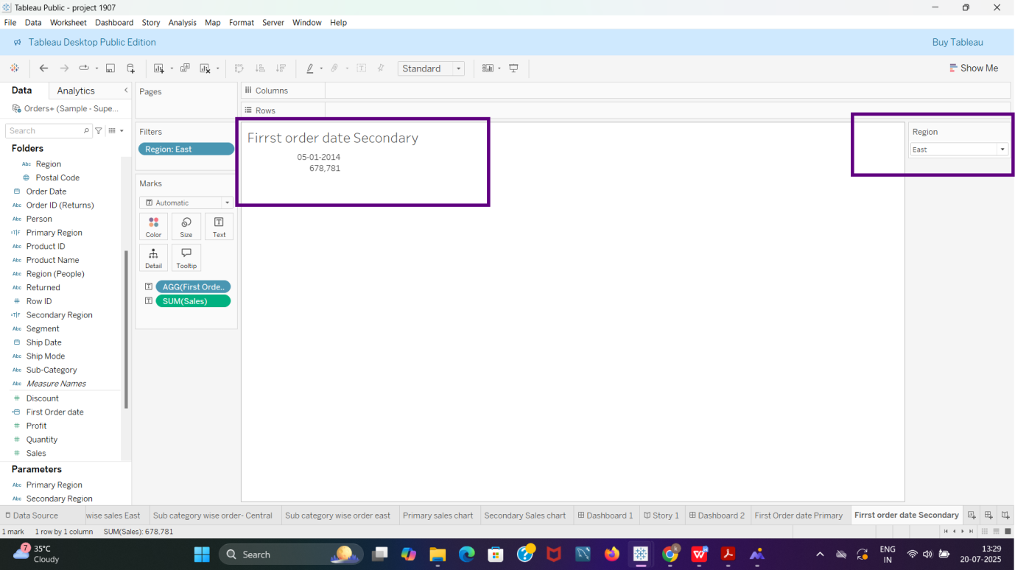

**Step 2**

* **Total Sales, Average Sales per Order, No. Of customers, No. Of Orders, No. Of Products in Sale (Primary and Secondary Region)**
* **Primary Region (Central)**

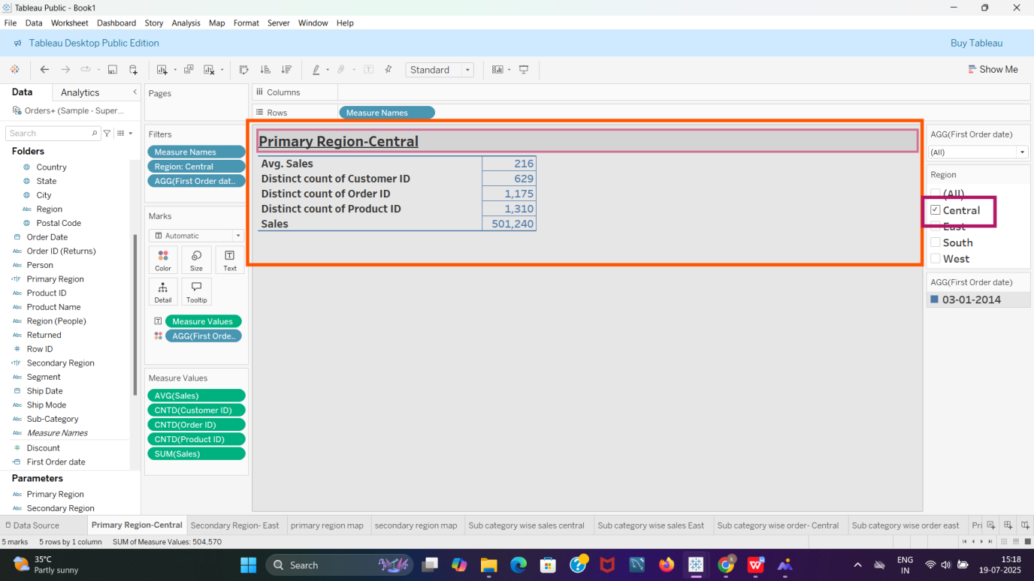

* **Secondary Region**

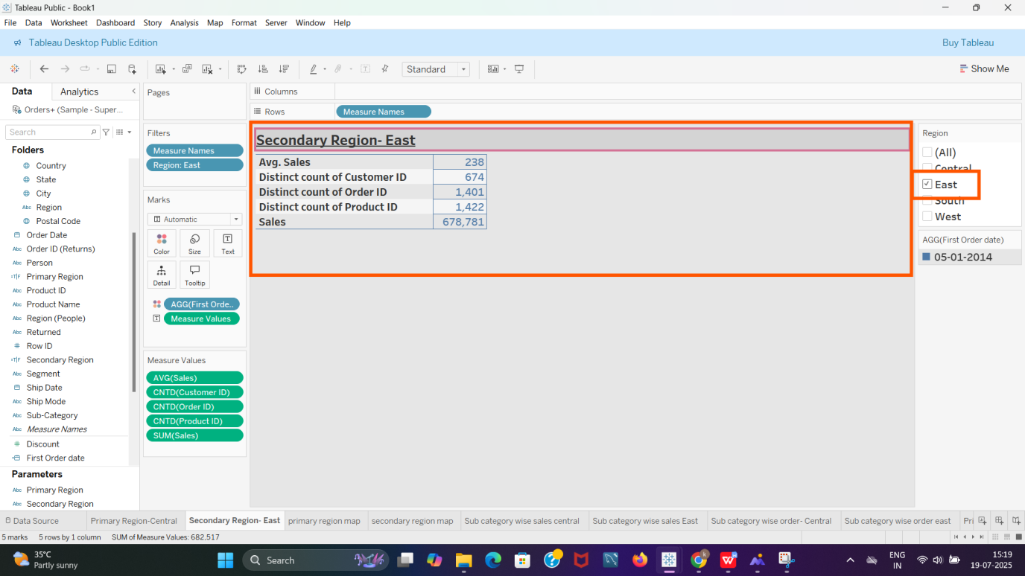

**Step 3**

* **Maps (Primary and Secondary Region)**
* **Primary Region (Central)**

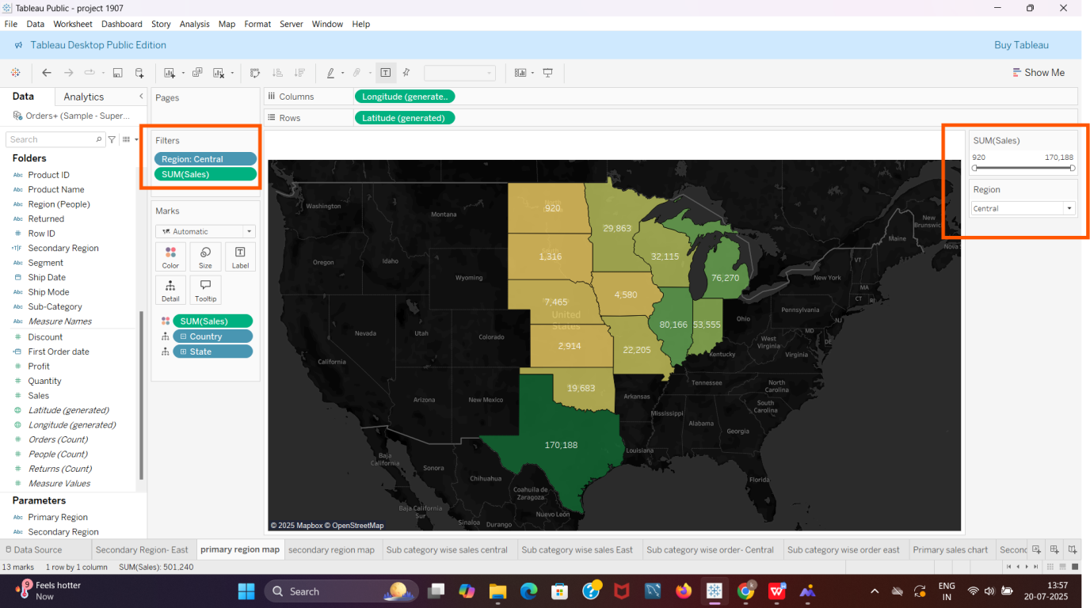

* **Secondary Region (East)**

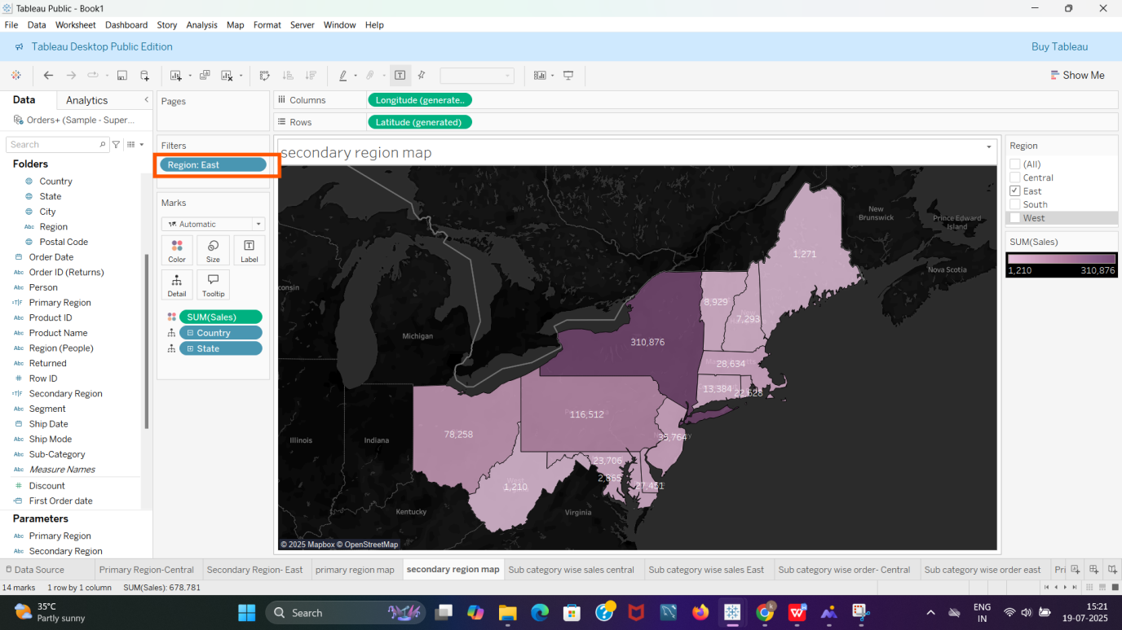

**Step 4**

* **Sub Category Wise Sales(Primary and Secondary Region)**
* **Sub Category Wise Sales, Central (Primary Region)**

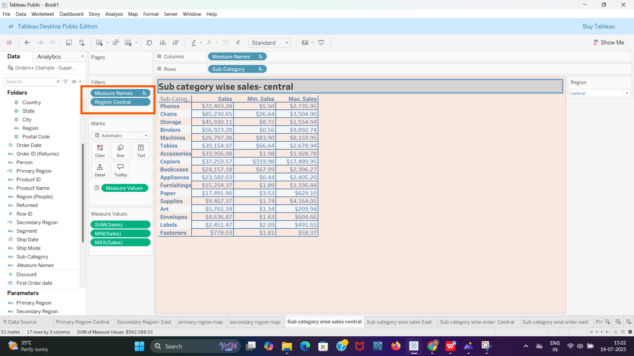

* **Sub Category Wise Sales, East (Secondary Region)**

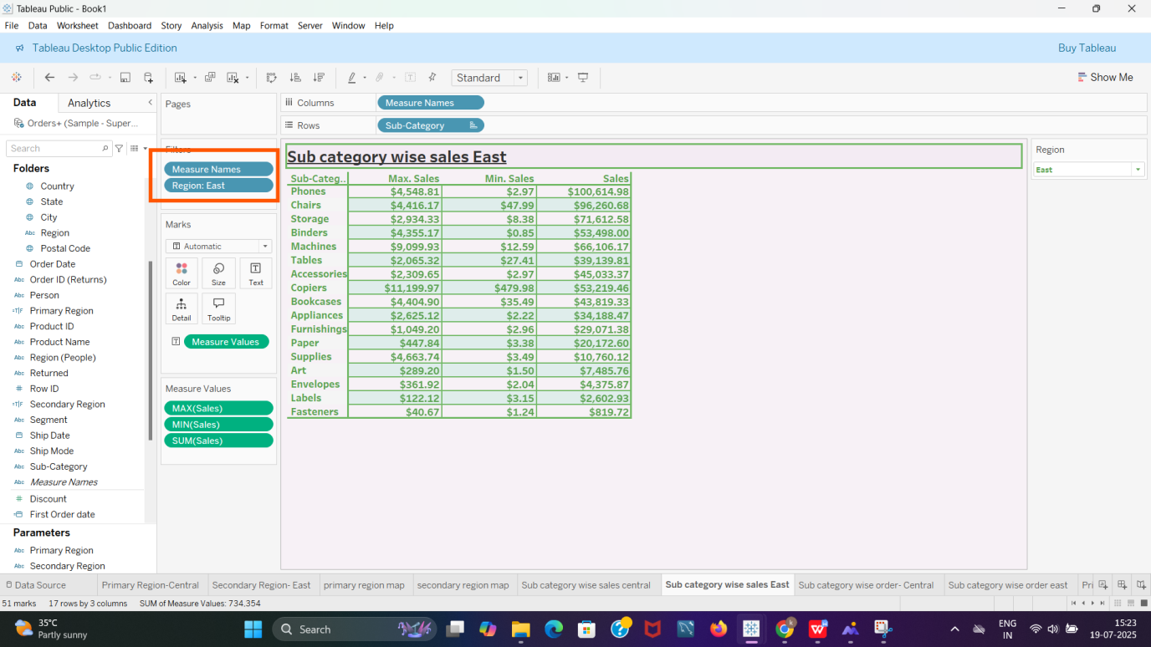

**Step 5**

* **Sub Category Wise Order Date(Primary and Secondary Region)**
* **Sub Category wise Order Date (Primary Region, Central)**

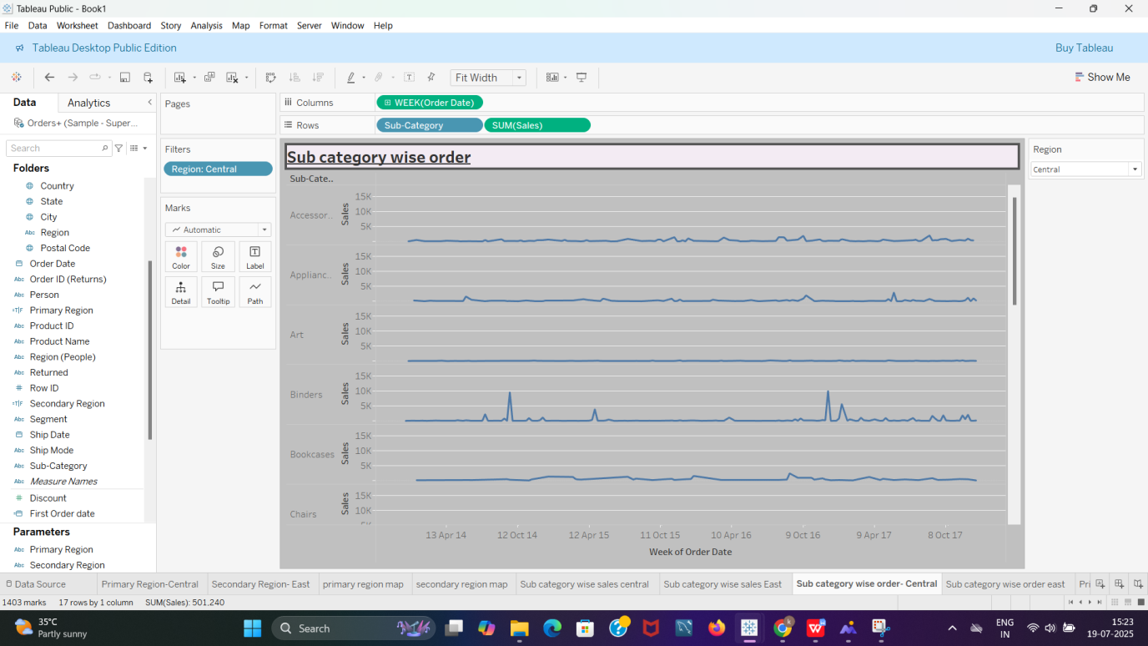

* **Sub Category wise Order Date (Secondary Region, East)**

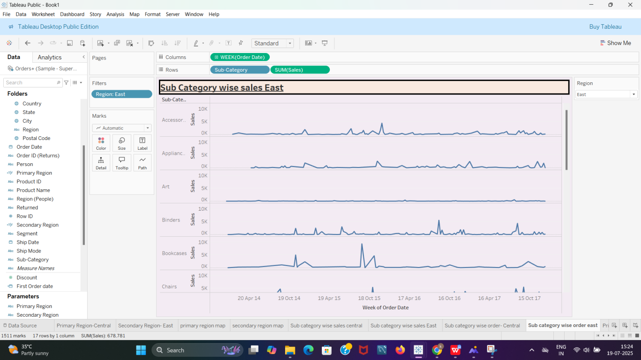

**Step 6**

* **Sales Bar Chart (Primary and Secondary Region)**
* **Sales Bar Chart (Primary Region)**

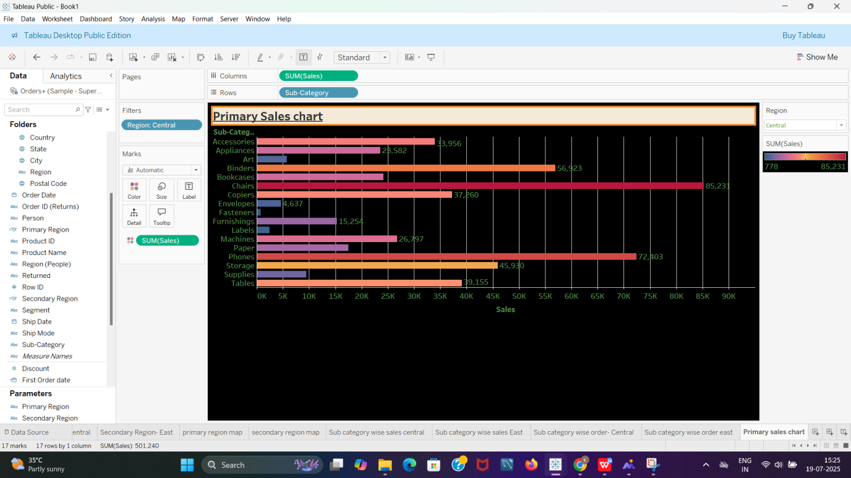

* **Sales Bar Chart (Secondary Region)**

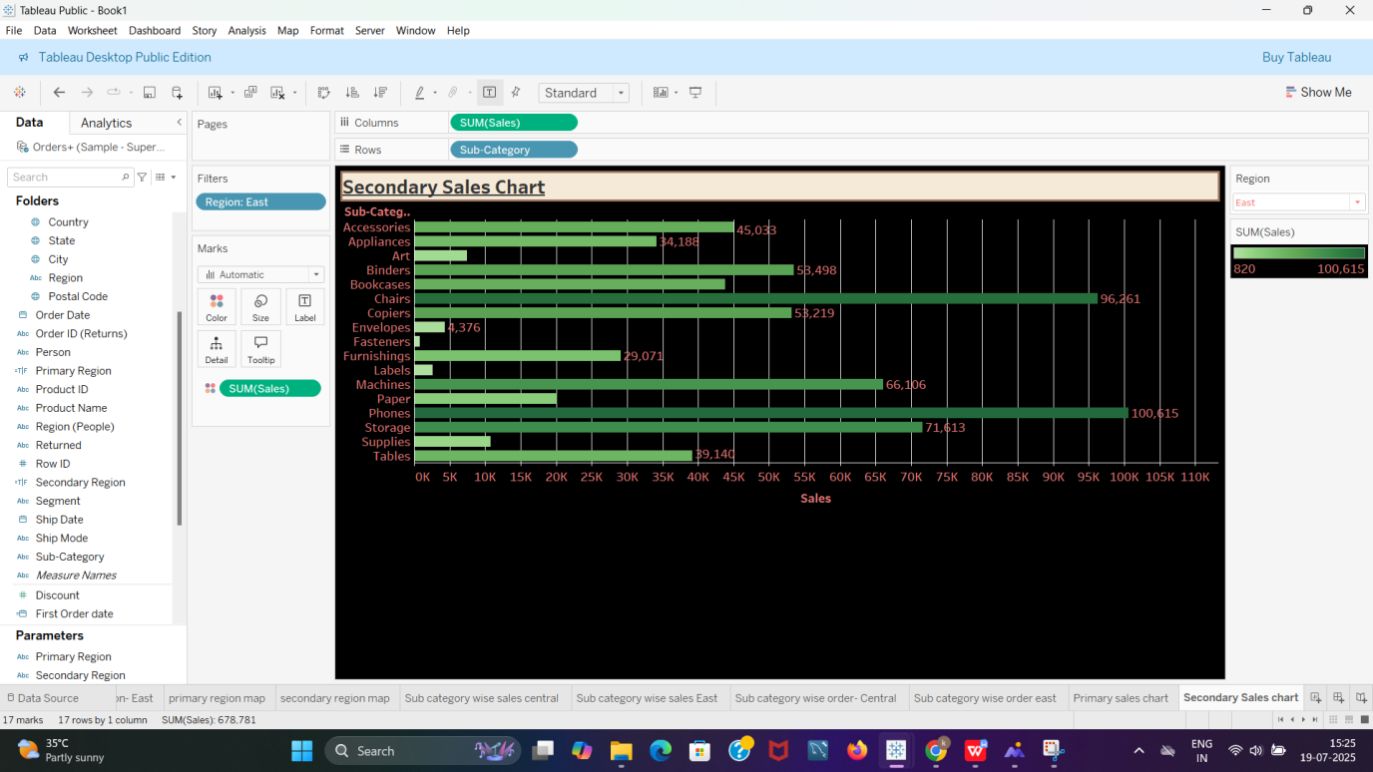

**Dashboard**

**Dashboard**

